PROPOSED ORDER TRACKING PROCESS
Chassis Classification for MTO (IS & IB) and Rush Orders
Purpose: Enable end-to-end, near real-time tracking of confirmed customer orders by carrying a single order reference number across S&OP, SAP, MES, rollout, stock and invoicing stages.

1. Business Problem
Institutional Sales (IS) and International Business (IB) orders are confirmed with agreed delivery dates. Orders are currently tracked manually in spreadsheets, and checking an order status requires emails and follow-ups across two or three systems.
- There is no single reference that consistently links the order across planning, production, stock, and invoicing records.
- Status visibility depends on manual coordination, which can delay responses and create inconsistent information.

2. Objective
Introduce an order reference number in Chassis Classification and carry it through each downstream transaction and data file. The proposed process will allow users to track an order from its release to MES through rollout, OK Tag, stock availability, and invoicing.

3. Scope and Order Reference
Order Category | Reference Number | Source / Creation Point
Rush Order | Order reference number | Generated when the order is created in the S&OP platform.
IS & IB Order | SAP sales order number | Created in SAP and used as the common order reference.

4. Proposed Solution
Add two fields to the existing order upload template for the Pithampur and Bhopal plants:
- SAP Order Type
- Order Reference Number
When an order is placed from SAP to MES, these fields will be transferred with the order. After MES confirms the order, the same information will be returned to SAP together with the other chassis characteristics and stored in Chassis Classification.

5. End-to-End Process Flow
- Order creation: Create the order in the S&OP platform for rush orders or create the sales order in SAP for IS & IB orders.
- Reference assignment: Use the S&OP-generated order reference for rush orders and the SAP sales order number for IS & IB orders.
- Template preparation: Download a prefilled order upload template from the S&OP tool. Where required, the user may split the order quantity before downloading.
- Order upload to MES: Upload the order from SAP to MES with Order Type and Order Reference Number.
- MES confirmation: Receive the order confirmation from MES. Return the reference number to SAP along with the remaining chassis characteristics.
- Downstream reporting: Capture the reference number in rollout, stock and invoice files and send the files to the S&OP tool.
- Status update: Update the relevant order in the S&OP tool so users can view the latest available status against the same reference number.

6. System and Template Changes
Area | Required Change | Purpose
S&OP platform | Generate / retain the order reference; provide prefilled template download; allow quantity split and status update. | Create one point of visibility for order progress.
SAP | Send Order Type and Order Reference Number to MES and receive them back with chassis characteristics. | Maintain the reference for Chassis Classification.
MES | Accept and return the new fields as part of order upload and confirmation. | Preserve traceability during production processing.
Data files | Add the reference number to rollout, stock, and invoice files. | Link downstream milestones to the original order.
Order templates | Modify templates used by Pithampur and Bhopal plants. | Standardize captures across both plants.

7. Proposed Screen / Template References

7.1 MES Order Upload Template
Figure 1. MES Order Upload Template

7.2 Chassis Classification
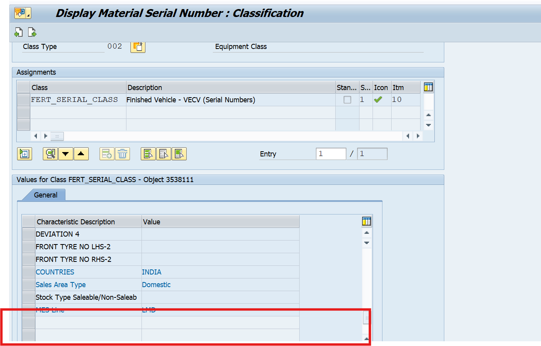
Figure 2. Chassis Classification

8. Expected Benefits
- End-to-end traceability using one reference number across S&OP, SAP, MES and downstream files.
- Faster order status checks with reduced dependence on emails and spreadsheet reconciliation.
- Improved visibility of production, rollout, stock, and invoice milestones.
- More consistent communication for committed delivery dates, especially for IS & IB and rush orders.

9. Implementation Considerations
- Finalize the field names, data format, field length and mandatory / optional rules for both new fields.
- Confirm interface mapping between S&OP, SAP and MES, including error handling for missing or duplicate references.
- Update rollout, stock and invoice file layouts and validate the corresponding S&OP imports.
- Complete end-to-end testing for rush, IS and IB order scenarios, including split quantities.
- Define user roles and ownership for manual status updates in the S&OP tool.

